**REPORTS:** **INTL 305**

**DEVELOPING ENGLISH LANGUAGE PROFICIENCY**

**ISSUE #0: GETTING STARTED**

Browser shows a ‘Page not found’ message after ‘Getting started’ link was clicked.

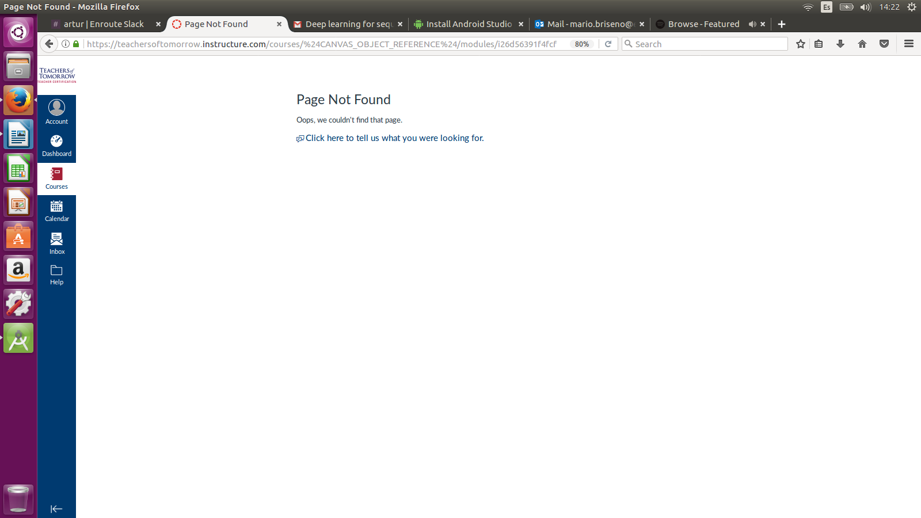

**ISSUE #1: L1 T1**

Because of the ISSUE 0, there’s no access at the first entry to L1 T1 until ‘Start Here’ link is clicked.

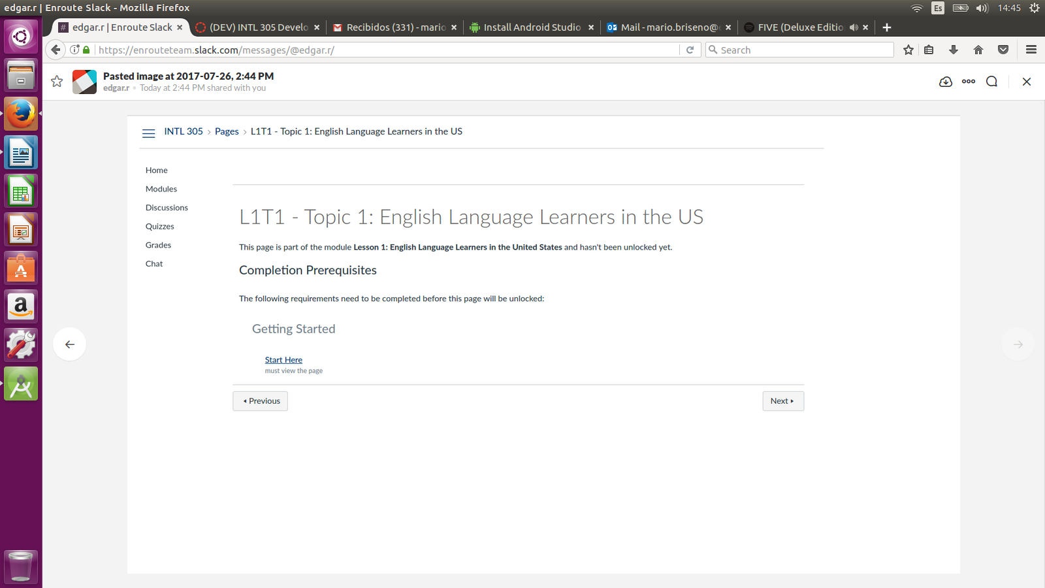

**ISSUE #2: L1 T1**

A URL is displayed as text.

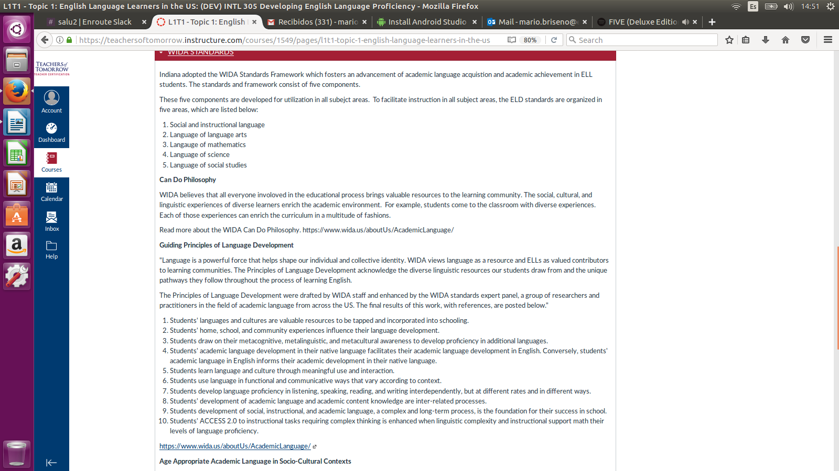

**ISSUE #3: L1 T1**

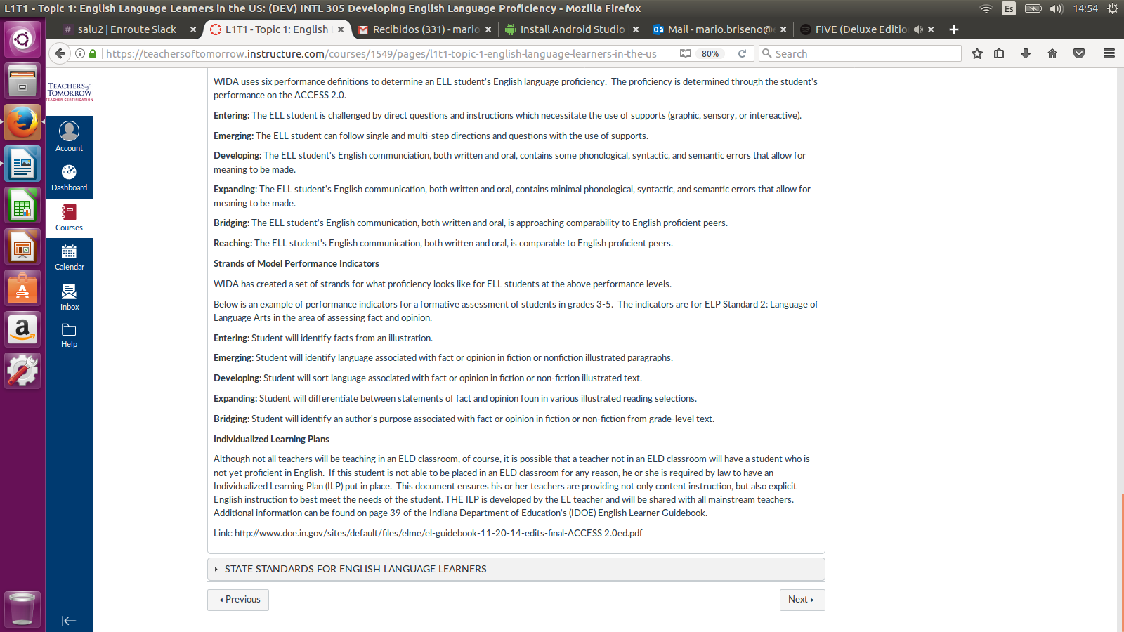A URL is displayed as text.

**ISSUE #4: L3 T1**

There’s too much space between two paragraphs. After some sentences there are two blank spaces. Check every module for every lesson in order to detect all the 2 blank spaces between sentences.

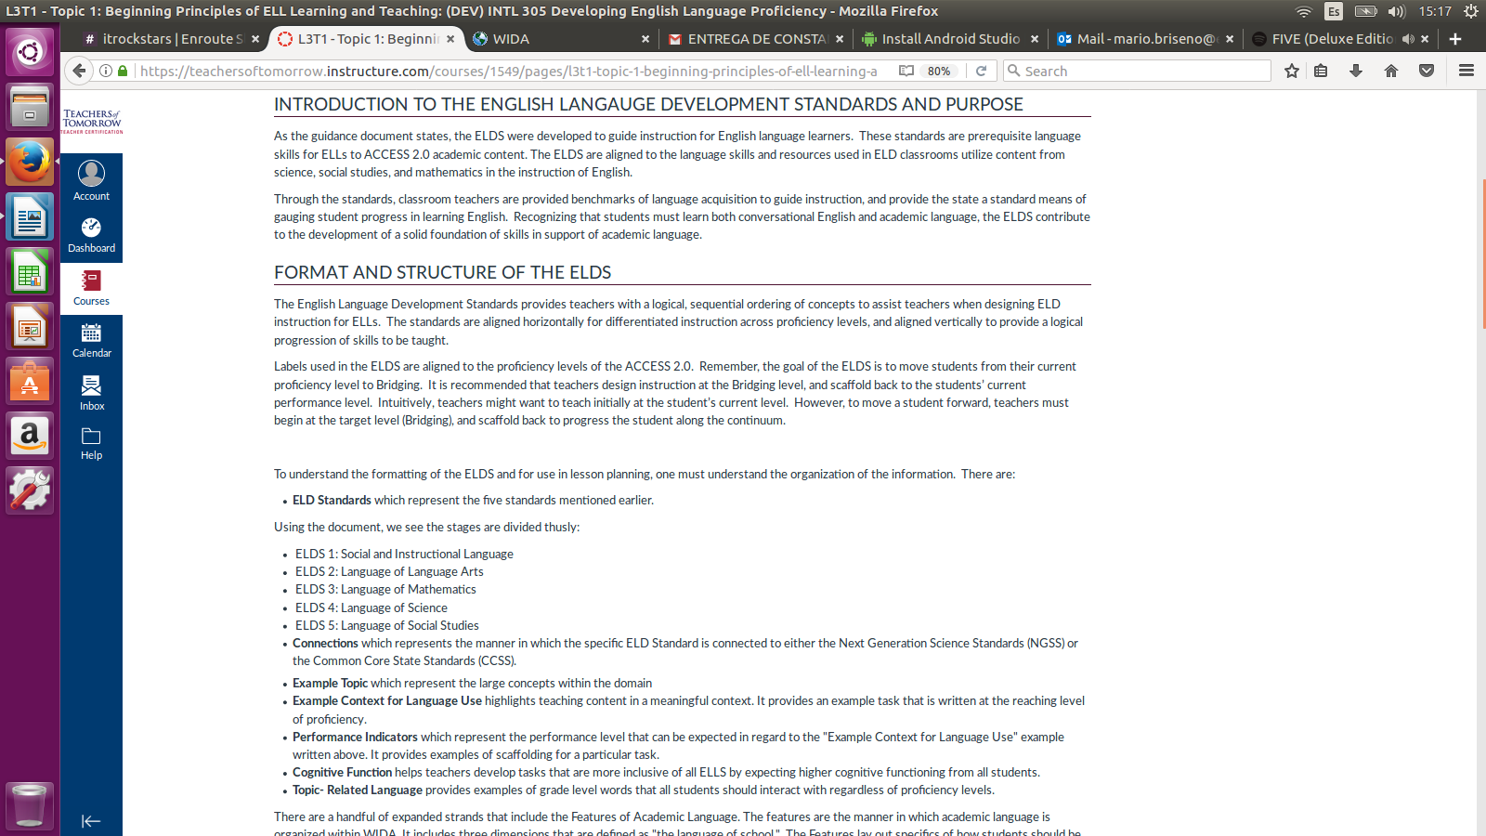

**SSUE #5: L3 T1**

A period is missing.

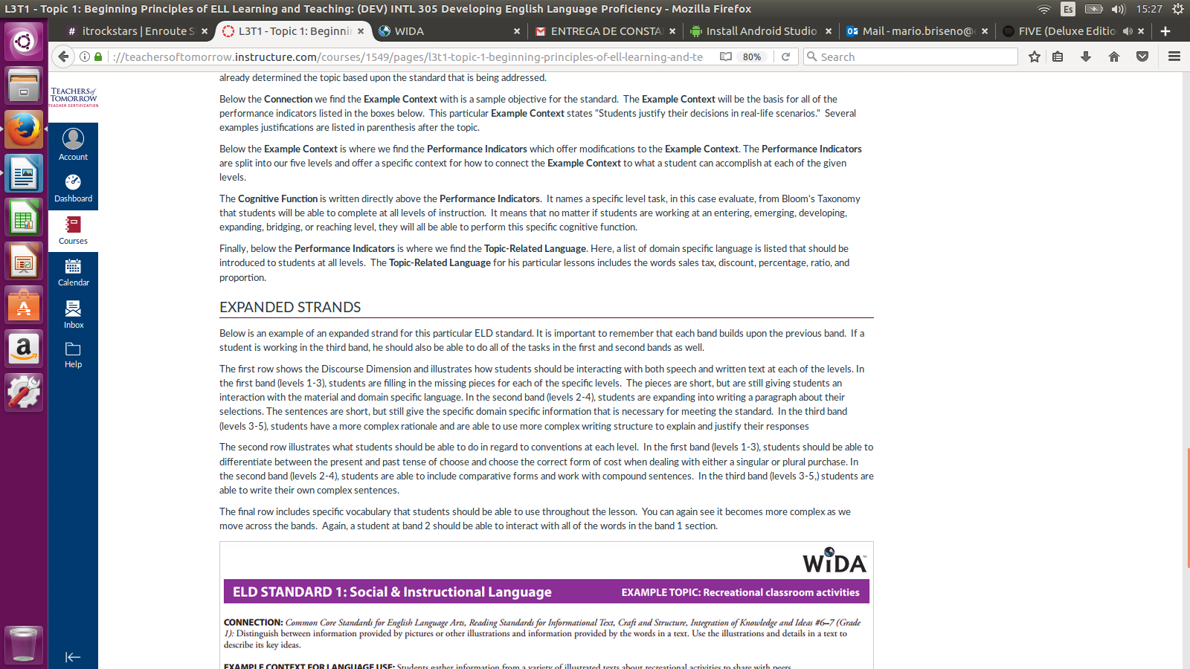

**ISSUE #6: L3 T2**

Image is too small.

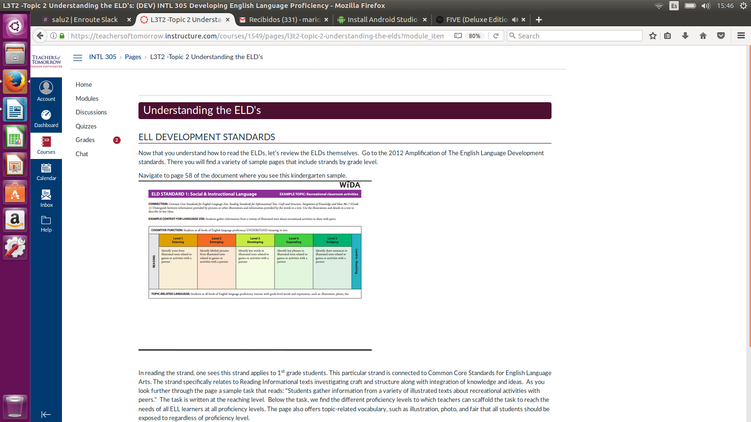

**ISSUE #7: L3 T3**

Images in L3 T3 are too small and one of them is kind of blurry.

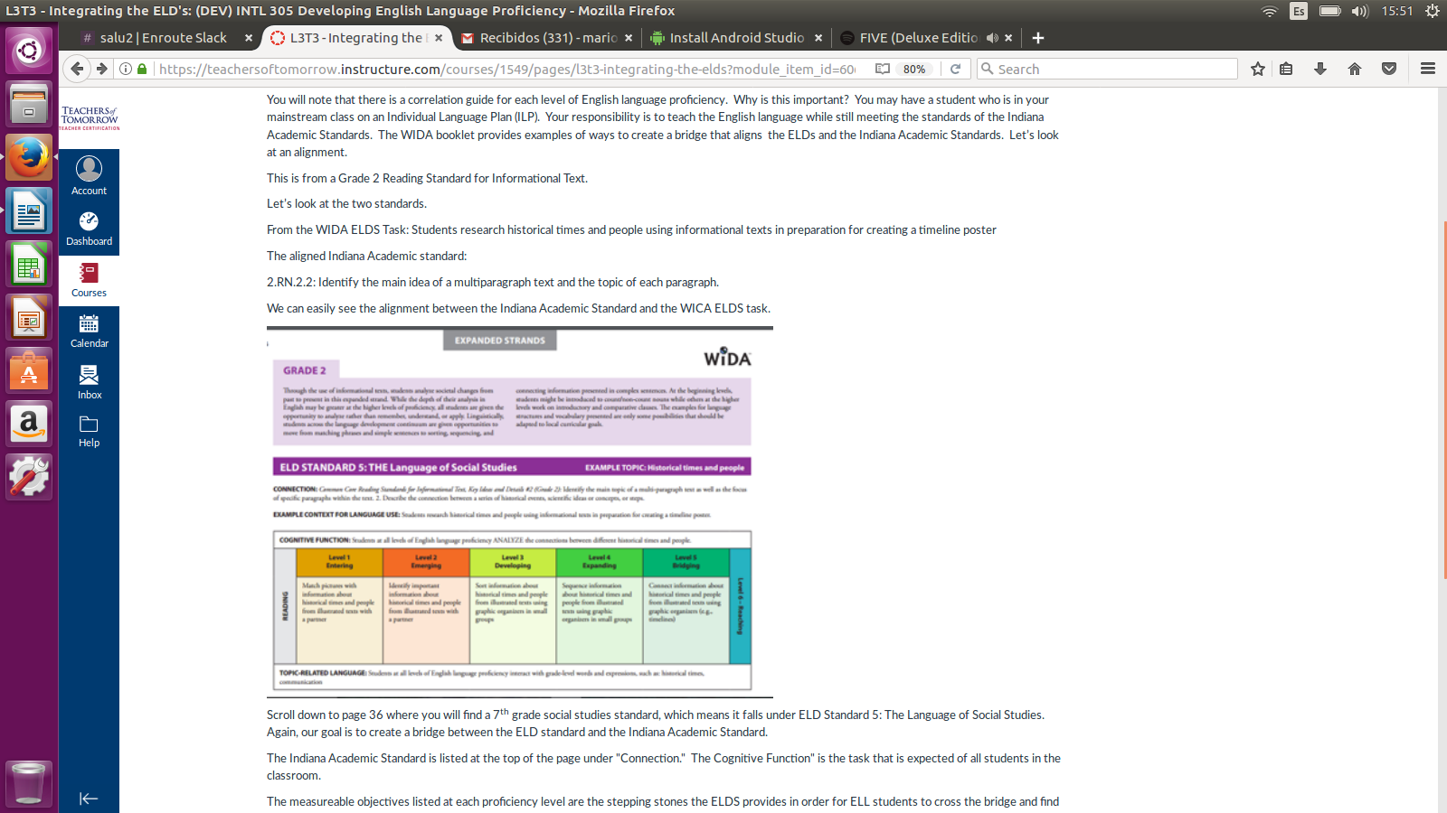

**ISSUE #8: L3 C1**

The URL is shown as text.

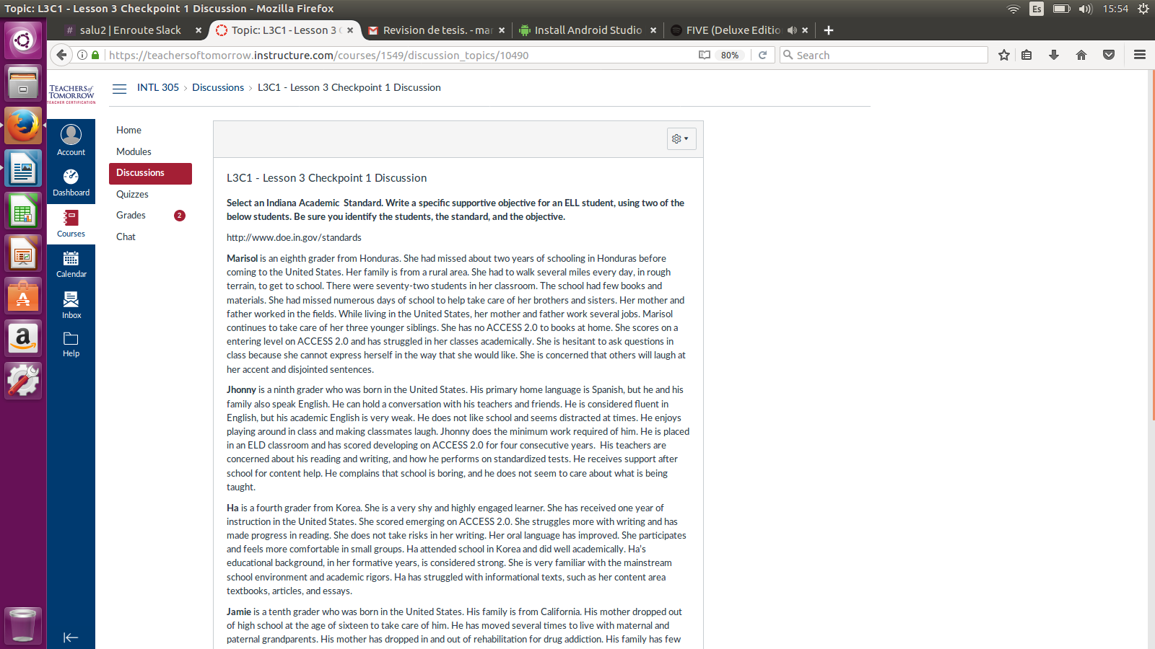

**ISSUE #9: L4 T1**

Expander toggler ‘TEACHER RESPONSIBILITIES’ doesn’t expand.

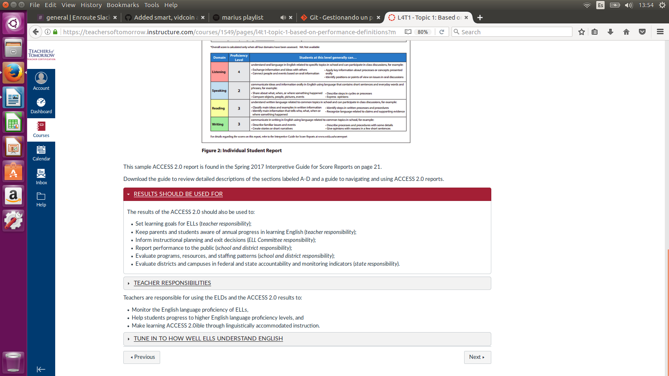

**ISSUE #10: L4 T2**

Images are too small. They can’t be seen.

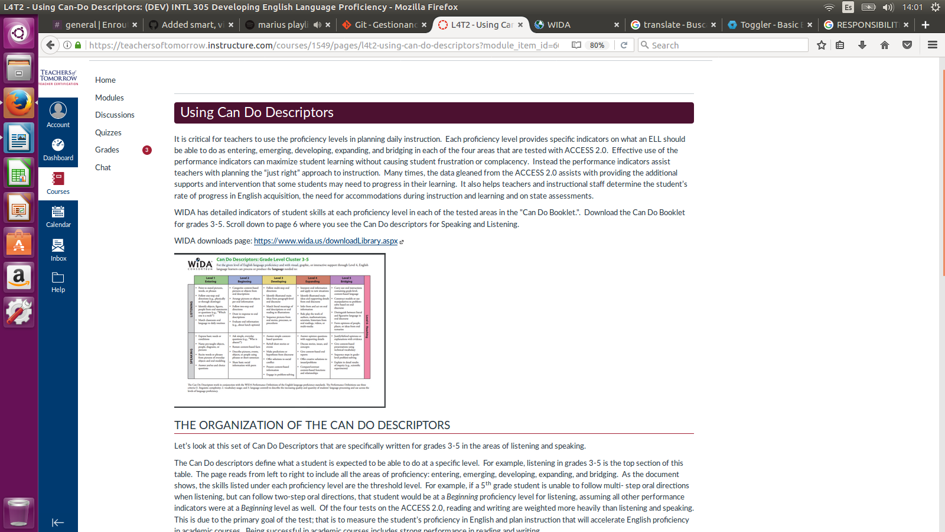

**ISSUE #11: L4 T3**

List elements should start with lower case letters.

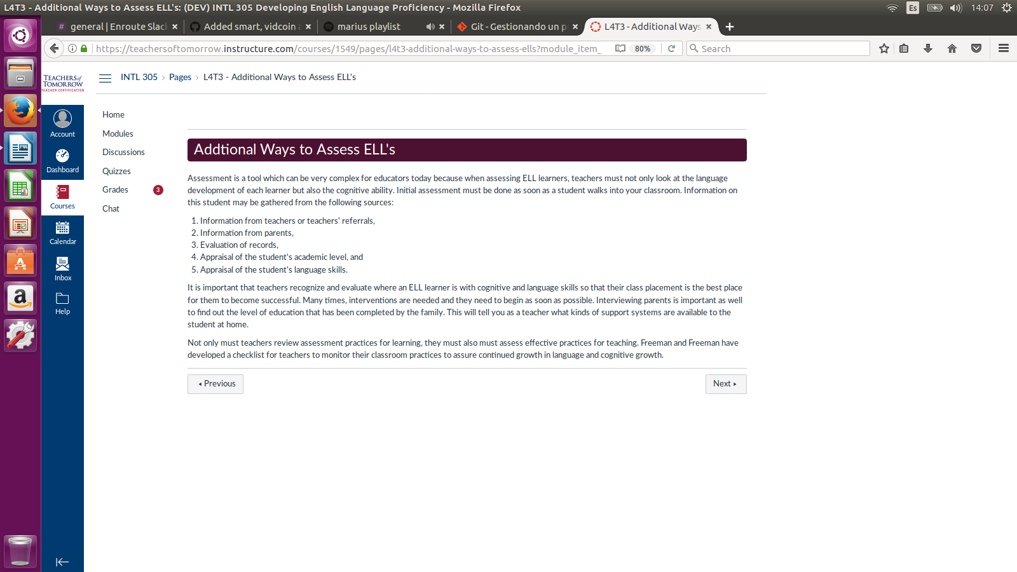

**ISSUE #12: L6 T1**

URL ‘words’ looks like is breaking the paragraph and the thumbnail video is too small.

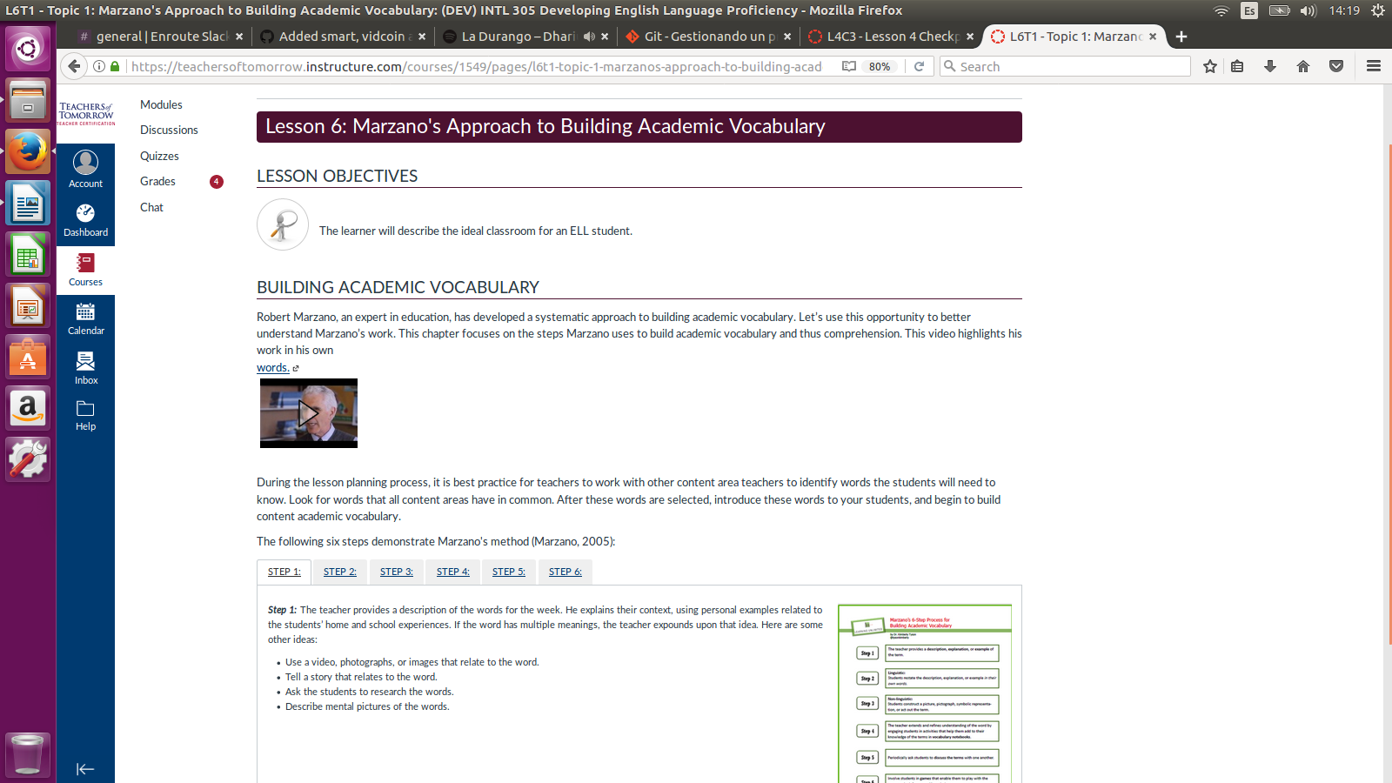

**ISSUE #13: L6 T1**

Step1, at L6 T1 , has a very small image within. Step 3 has the same ISSUE as ISSUE #12.

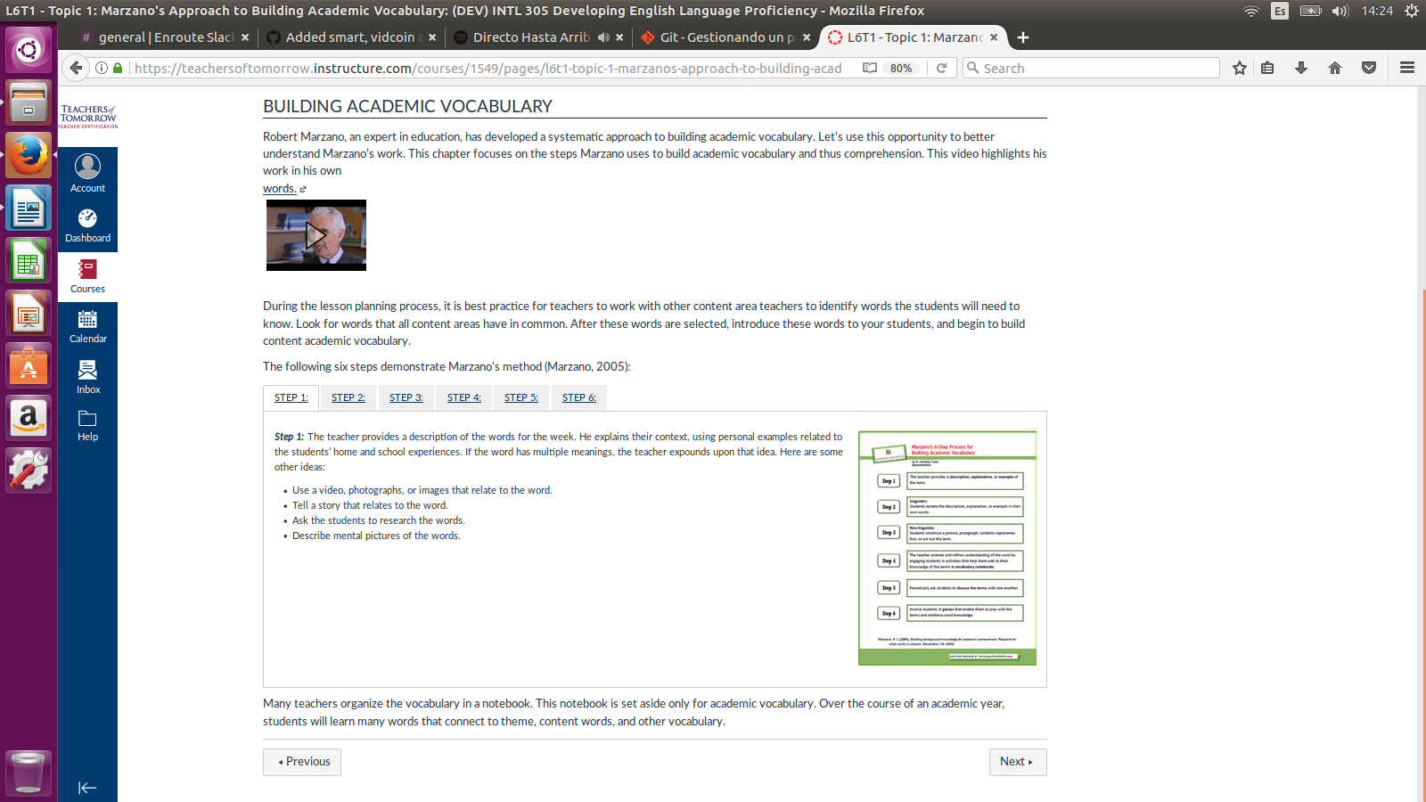

**ISSUE #14: L6 T3**

This box looks inconsistent with all the other past references and URLs. Other tabs like ‘CONTENTS’ has ISSUE #12. “[PROVIDE CONTEXT IN WRITING](https://teachersoftomorrow.instructure.com/courses/1549/pages/l6t3-topic-3-sentence-stems-for-speaking-and-writing?module_item_id=60641" \l "kl_panel_5_content)” tab has a broken URL.

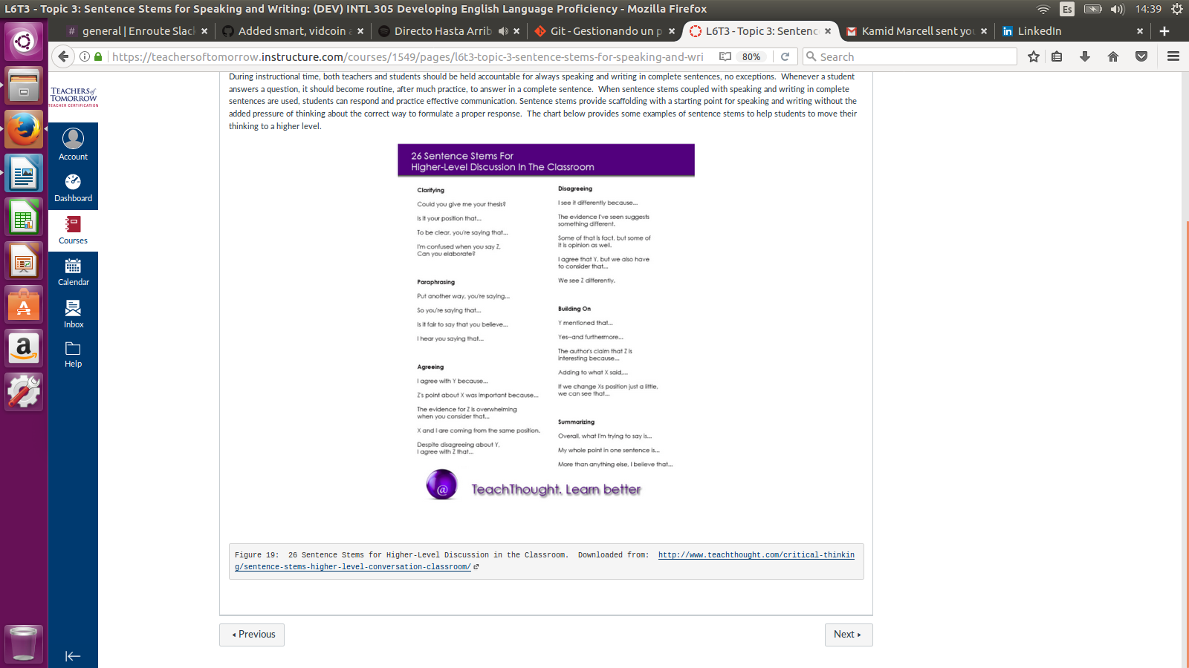

**ISSUE #15: L6 T4**

Video thumbnail looks weird. Table at the same lesson topic is too small.

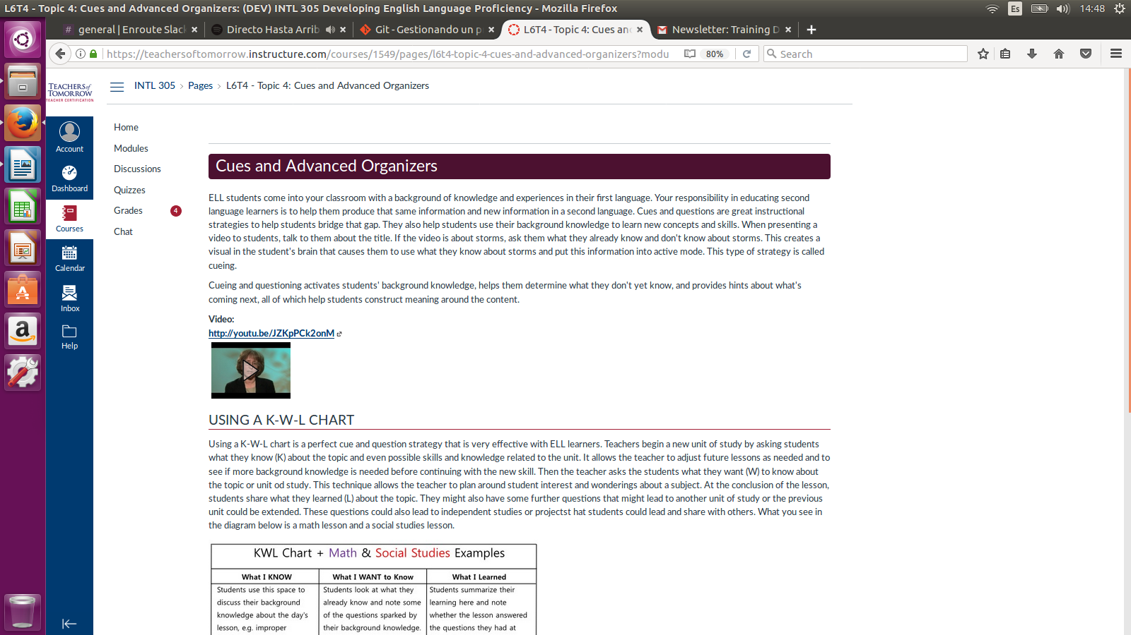

**ISSUE #16: L6 T5**

Images in tabs are too small.

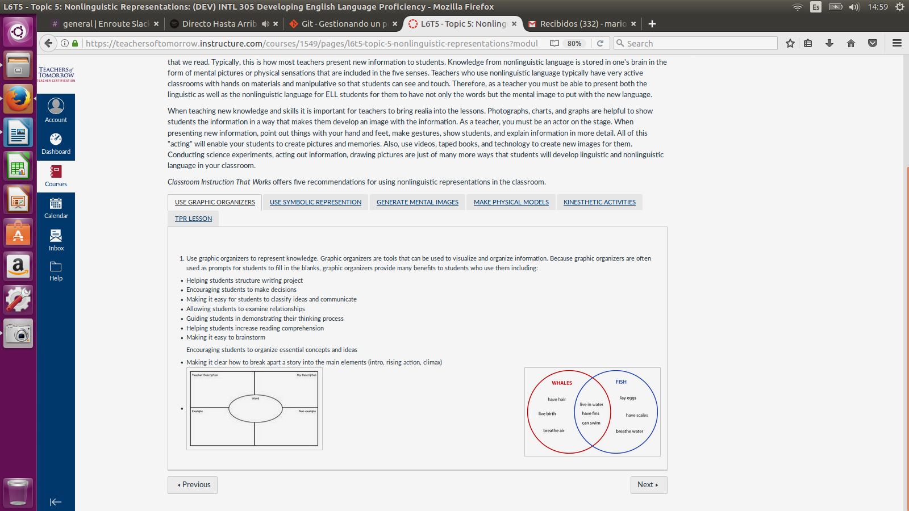

**ISSUE #17: L7 T1**

Videos thumbnail looks weird.

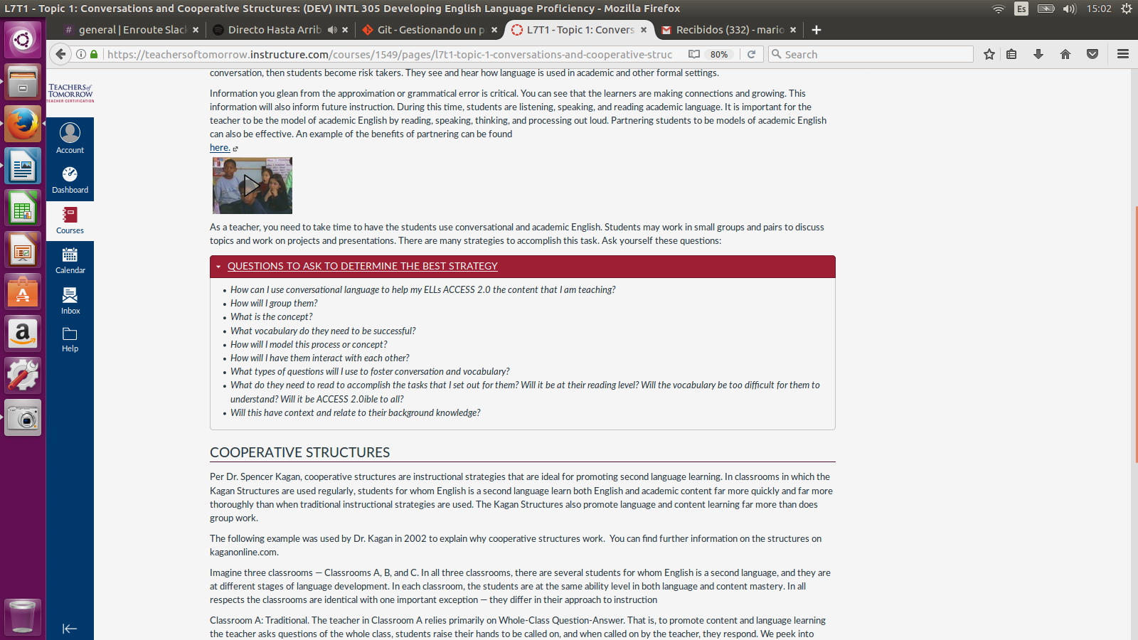

**ISSUE #18: L7 T2**

Videos thumbnail looks weird. At the end of the web page there’s a small image.

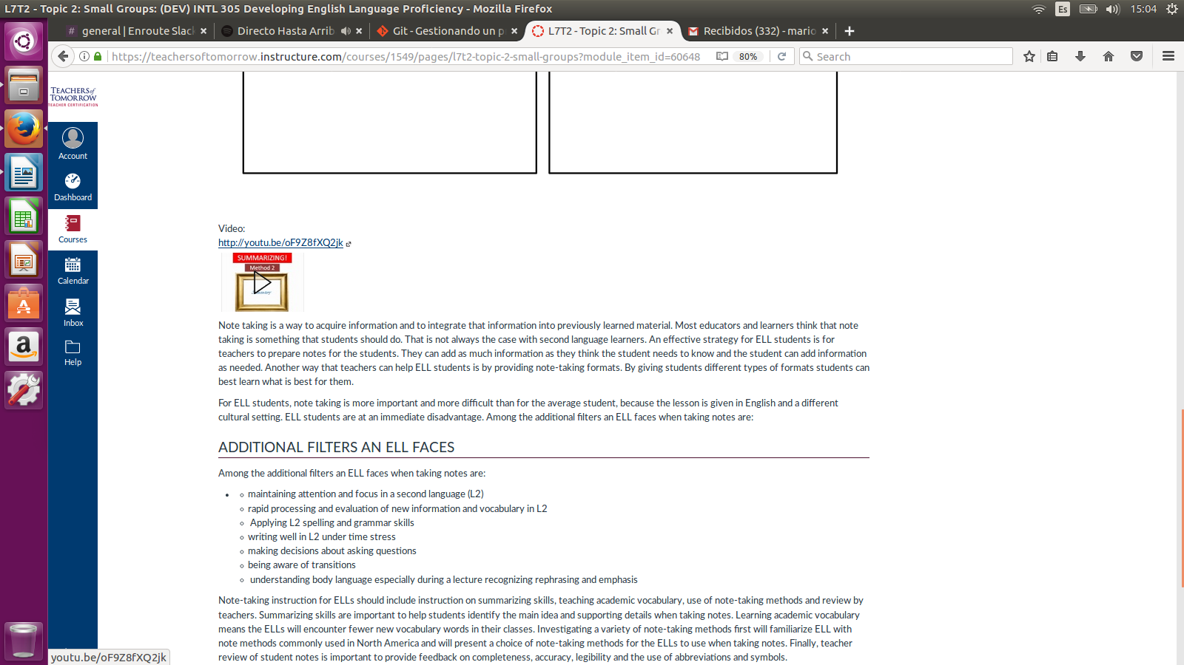

**ISSUE #18: L7 T3**

A period is missing in some content paragraphs and the ‘Reinforcing Effort’ tab has a video problem related to tits thumbnail.

